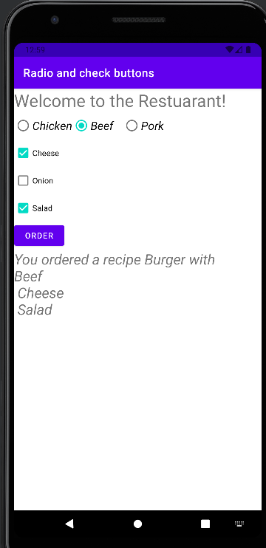

package com.example.radioandcheckbuttons  
  
import android.annotation.SuppressLint  
import android.os.Bundle  
import android.widget.*  
import androidx.appcompat.app.AppCompatActivity  
  
class MainActivity : AppCompatActivity() {  
 @SuppressLint("SetTextI18n")  
 override fun onCreate(savedInstanceState: Bundle?) {  
 super.onCreate(savedInstanceState)  
 setContentView(R.layout.*activity_main*)  
  
 val view = findViewById<TextView>(R.id.*view*)  
 val btnOrder = findViewById<Button>(R.id.*btnOrder*)  
 val cbCheese = findViewById<CheckBox>(R.id.*cbCheese*)  
 val cbSalad = findViewById<CheckBox>(R.id.*cbSalad*)  
 val cbOnion = findViewById<CheckBox>(R.id.*cbOnion*)  
  
 btnOrder.setOnClickListener **{** val rgmeat = findViewById<RadioGroup>(R.id.*rgmeat*)  
 val checkedMeatRadioButtonId = rgmeat.*checkedRadioButtonId* val meat = findViewById<RadioButton>(checkedMeatRadioButtonId)  
  
 val cheese = cbCheese.*isChecked* val salad = cbSalad.*isChecked* val onion = cbOnion.*isChecked* view.*text*= "You ordered a recipe Burger with \n"+  
 "${meat.*text*}"+  
 (if (cheese) "\n Cheese" else "" )+  
 (if (onion) "\n onion" else "")+  
 (if (salad) "\n Salad" else "")  
  
 //View.text = orderString  
 **}** }  
}

<?xml version="1.0" encoding="utf-8"?>  
<androidx.constraintlayout.widget.ConstraintLayout xmlns:android="http://schemas.android.com/apk/res/android"  
 xmlns:app="http://schemas.android.com/apk/res-auto"  
 xmlns:tools="http://schemas.android.com/tools"  
 android:layout_width="match_parent"  
 android:layout_height="match_parent"  
 tools:context=".MainActivity">  
  
  
 <TextView  
 android:id="@+id/textView2"  
 android:layout_width="wrap_content"  
 android:layout_height="wrap_content"  
 android:text="Welcome to the Restuarant!"  
 android:textSize="30sp"  
 app:layout_constraintBottom_toBottomOf="parent"  
 app:layout_constraintEnd_toEndOf="parent"  
 app:layout_constraintHorizontal_bias="0.0"  
 app:layout_constraintStart_toStartOf="parent"  
 app:layout_constraintTop_toTopOf="parent"  
 app:layout_constraintVertical_bias="0.0" />  
  
 <RadioGroup  
 android:id="@+id/rgmeat"  
 android:layout_width="wrap_content"  
 android:layout_height="wrap_content"  
 android:orientation="horizontal"  
 app:layout_constraintTop_toBottomOf="@+id/textView2"  
 tools:ignore="MissingConstraints">  
  
 <RadioButton  
 android:id="@+id/rbchicken"  
 android:layout_width="wrap_content"  
 android:layout_height="wrap_content"  
 android:checked="true"  
 android:text="Chicken"  
 android:textSize="20sp"  
 android:textStyle="italic"  
 app:layout_constraintStart_toStartOf="parent"  
 app:layout_constraintTop_toBottomOf="@+id/textView2" />  
  
 <RadioButton  
 android:id="@+id/rbbeef"  
 android:layout_width="88dp"  
 android:layout_height="48dp"  
 android:text="Beef"  
 android:textSize="20sp"  
 android:textStyle="italic"  
 app:layout_constraintEnd_toEndOf="parent"  
 app:layout_constraintHorizontal_bias="0.0"  
 app:layout_constraintStart_toEndOf="@+id/rbpork"  
 app:layout_constraintTop_toBottomOf="@+id/textView2" />  
  
 <RadioButton  
 android:id="@+id/rbpork"  
 android:layout_width="wrap_content"  
 android:layout_height="wrap_content"  
 android:text="Pork"  
 android:textSize="20sp"  
 android:textStyle="italic"  
 app:layout_constraintStart_toEndOf="@+id/rbchicken"  
 app:layout_constraintTop_toBottomOf="@+id/textView2" />  
  
  
 </RadioGroup>  
  
 <CheckBox  
 android:id="@+id/cbCheese"  
 android:layout_width="wrap_content"  
 android:layout_height="wrap_content"  
 android:text="Cheese"  
 app:layout_constraintTop_toBottomOf="@+id/rgmeat"  
 tools:ignore="MissingConstraints" />  
  
 <CheckBox  
 android:id="@+id/cbSalad"  
 android:layout_width="wrap_content"  
 android:layout_height="wrap_content"  
 android:text="Salad"  
 app:layout_constraintTop_toBottomOf="@+id/cbOnion"  
 tools:ignore="MissingConstraints" />  
  
 <CheckBox  
 android:id="@+id/cbOnion"  
 android:layout_width="wrap_content"  
 android:layout_height="wrap_content"  
 android:text="Onion"  
 app:layout_constraintStart_toStartOf="parent"  
 app:layout_constraintTop_toBottomOf="@+id/cbCheese" />  
  
 <Button  
 android:id="@+id/btnOrder"  
 android:layout_width="wrap_content"  
 android:layout_height="wrap_content"  
 android:text="Order"  
 app:layout_constraintStart_toStartOf="parent"  
 app:layout_constraintTop_toBottomOf="@+id/cbSalad" />  
  
 <TextView  
 android:id="@+id/view"  
 android:layout_width="match_parent"  
 android:layout_height="195dp"  
 android:text="Order Details"  
 android:textSize="25sp"  
 android:textStyle="italic"  
 app:layout_constraintTop_toBottomOf="@+id/btnOrder"  
 tools:ignore="MissingConstraints"  
 tools:layout_editor_absoluteX="0dp" />  
  
  
</androidx.constraintlayout.widget.ConstraintLayout>